LAB TASK
Configure Dynamic Routing Using RIP
You are given a network topology consisting of multiple routers and PCs connected through serial and FastEthernet interfaces (as shown in the diagram).

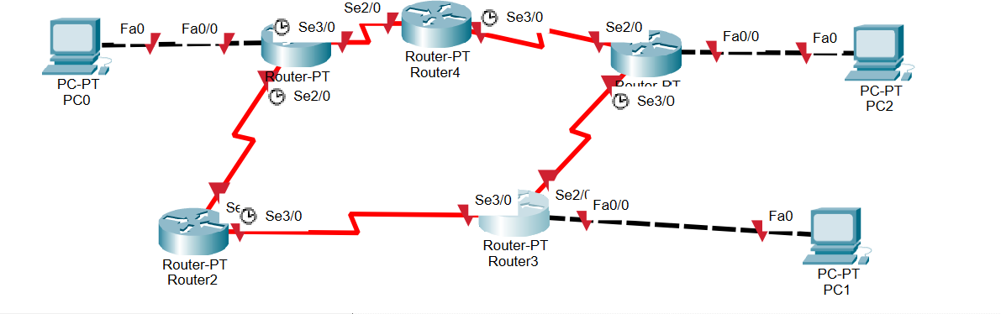
Objective:
Configure Routing Information Protocol (RIP) on all routers to enable full connectivity between all networks.
Requirements:
- IP Addressing
  - Assign appropriate IP addresses to all:
    - Router interfaces (Serial and FastEthernet)
    - PCs
  - Ensure each network uses a valid and unique subnet.
- RIP Configuration
  - Configure RIP Version 2 on all routers.
  - Add all directly connected networks using the network command.
  - Disable auto-summary.
- Connectivity
  - Ensure that:
    - PC0 can communicate with PC1 and PC2.
    - PC1 can communicate with PC0 and PC2.
    - PC2 can communicate with PC0 and PC1.

